Asbury NHPPD- PCC

Presented to: | ThriveWell Tech / Jon Morrison, Jason Hershey
Version Number: | Draft V3
Revised Date: | 22-07-2025

Table of Contents
1 Overview 3
1.1 Project Overview 3
1.2 Asbury Communities 3
2 Project Requirements 3
3 Data Sources 4
4 ETL Process Design 4
4.1 Extraction 4
4.2 Trasformation 4
4.3 Loading 4
5 Data Mapping 4
6 Workflow and Scheduling 4
7 Error Handling and Logging 4
8 Testing and Validation 4
9 Documentation and Reporting 5
10 Maintenance and Support 5
11 Appendices 5
12 Technical Details 5
13 Qlik Reporting Sheets 5
14 UAT Cases 5
15 Changes from MyUnity 5
Version Change Control 6

1 Overview

NHPPD (Nursing Hours Per Patient Day) is a staffing metric used in Health Care to measure the number of direct nursing care hours provided to each patient within a 24-hour period. It helps Hospitals and Health Care facilities assess nurse staffing levels relative to patient care demands. Data is systematically processed through AWS Glue and Redshift, then visualized in a Qlik application for better decision-making.

1.1 Project Overview
Overview
Project Name | Asbury NHPPD- PCC
Project Description | The report provides a detailed insight of hours worked by all nurses and census status for all Asbury communities those gone live on PCC beginning Feb’24 onwards.  Refer to Section 1.2 for Asbury Communities.
Project Start Date | January 2025
Stake Holders | Jason Hershey
NHPPD Go live in Production | 17 July 2025
Additional Notes: MyUnity data is not currently integrated into this application. As a result, NHPPD (Nursing Hours Per Patient Day) information is available only from the respective PCC go-live dates for each community. The report includes data starting from January 1, 2025.

1.2 Asbury Communities
Below listed are the Communities the NHPPD report is prepared for.
IL - Independent Living
AL – Assisted Living
SNF - Skilled Nursing Facility
Communities | Level of Care
Asbury Solomons | SNF
Asbury Methodist Village | SNF
Bethany Village | SNF
Springhill | SNF
Riverwoods | SNF
Normandie Ridge | SNF

Includes both Facility code 61 (SNF) and 62 (Household)
1.3 Department and Job Code’s of Asbury Communities for NHPPD scope
Department – Nursing Services
Job Code – NU0001 , NU0008 , NU0009 , NU0012 , NU0015 , NU0018
Includes all Job Codes in specific Payroll Based Journal (PBJ) job code families. See data table for list of all included job codes.
Job Title | Job #
Registered Nurse | 7
Licensed Practical / Vocational Nurse | 9
Certified Nurse Aide | 10
Medication Aide/Technician | 12

Nursing hours and in-house occupancy information for the Skilled Nursing Facility
Includes all hours reported through Asbury’s internal time system (Kronos / UKG)
Includes Associates and Agency (if reported through Kronos/UKG)
For NHPPD Reporting Code and Earning Code refer to the document .
NHPPD Reporting and Earning Code.xlsx

2 Project Requirements
This section provides the detailed Business and Technical Requirements to deliver this project.

Business Requirements:
- Consolidated reporting of nursing hours from multiple systems including PCC, Ultipro, and GP, enriched with static budget files.
- Visualization of NHPPD KPIs and staffing data in Qlik dashboards for non-technical stakeholders.
- Inclusion of various levels of care: Independent Living (IL), Assisted Living (AL), and Skilled Nursing Facility (SNF).
- Automation of data extraction, transformation, and loading to reduce manual intervention and human error.
- Ability to validate census fluctuations and staffing effectiveness in near real-time.
- Backup data ingestion for contingency in case of data unavailability or extraction issues.

Technical Requirements:
The technical environment and tools required to support the successful implementation of the NHPPD Report include:
Infrastructure:
- Cloud Provider: AWS
- Database: Amazon Redshift (Data Warehouse)
- Storage: AWS S3 (Raw and processed data)
- ETL Orchestration: AWS Glue
- Data Migration: AWS DMS
- ODBC Connector: NetSuite ODBC Driver for data extraction
Software:
- BI Tool: Qlik Sense
- Data Sources Integration: APIs/Connectors for:
  - Point Click Care (PCC)
  - Ultipro
  - Great Plains (GP)
  - Netsuite
  - PbjLog
  - Kronos
  - Budget Static Files (CSV, Excel
Processing:
- ETL Framework: Custom Glue Jobs using PySpark/Scala
- Data Format: Parquet, JSON, CSV (as applicable)
- Transformation Patterns:
  - Slowly Changing Dimensions (SCD)
  - HUDI transformations for incremental data load
  - Standardization and data cleansing logic
Scheduling:
- Scheduler: AWS Glue Triggers & CloudWatch Events
- Job Timings: Twice daily (2:00 AM and 11:00 AM EST for extraction and transformation).
- For more details on job scheduling refer to section 6.
Security & Access:
- IAM Roles for access control to Glue, S3, Redshift
- Audit Logs for ETL activity tracking
- Secure FTP for file-based data inputs
Performance Considerations:
- Optimized Redshift table designs using sort keys and distribution styles
- Monitoring via CloudWatch Metrics for ETL jobs and Redshift usage

3 Data Sources
Below listed are the data sources for this project.
- Data Sources (including type) - Point Click Care (PCC), Ultipro, GreatPlains, NetSuite, Pbjlog, Budget static file
- Format - Raw/source data
- Location – AWS S3

4 ETL Process Design

4.1 Extraction
- Source Systems: Source systems used for this report are Point Click Care (PCC), Ultipro, GP, Netsuite.
- Data Extraction Methods: AWS DMS, NetSuite ODBC Driver

4.2 Transformation
- Data Cleaning: AWS Glue used for data validation, cleansing, and standardization.
- Data Transformation Rules: Used SCD and HUDI transformations on the data in AWS Glue.

4.3 Loading
- Target Systems: AWS Redshift
- Loading Methods: AWS Glue used for loading data.

5 Jobs and Data Mapping
- Source to Target Mapping: Manual mapping of source data fields to target data fields.
- Jobs
- Data Mapping

6 Workflow and Scheduling
- ETL Workflow: Visual representation of the ETL process flow.
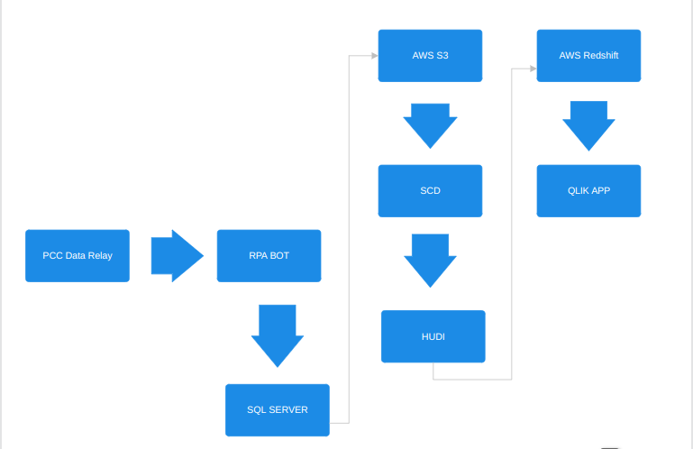
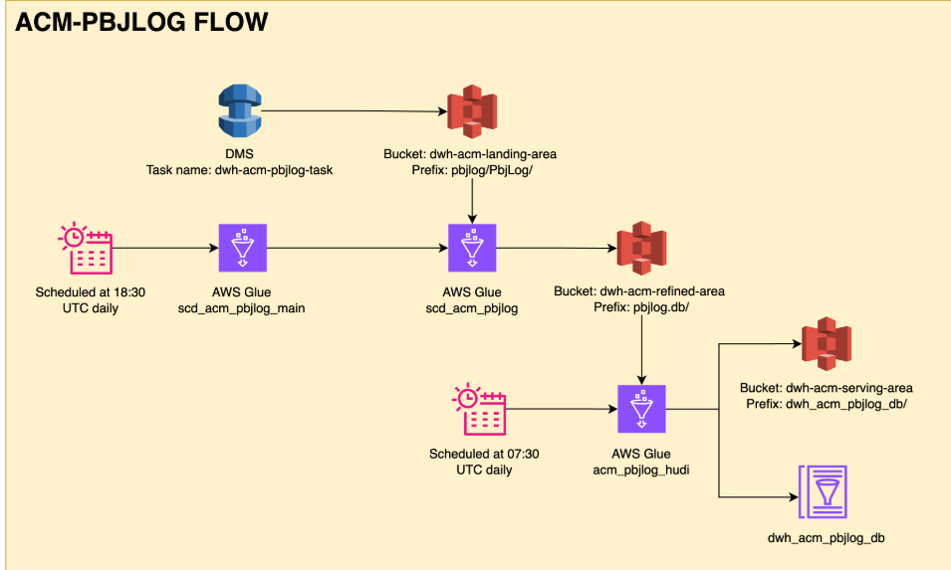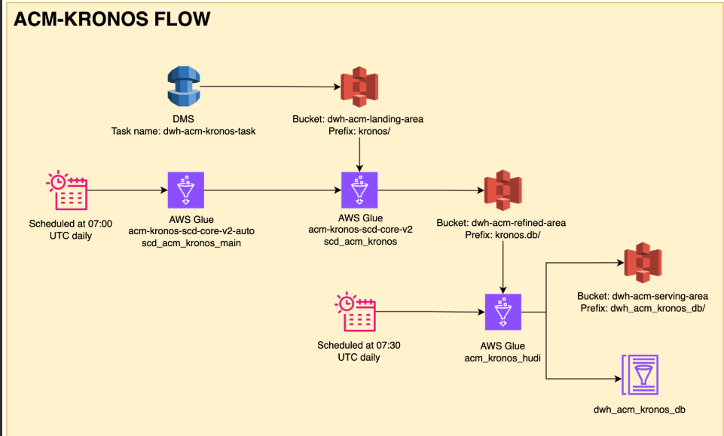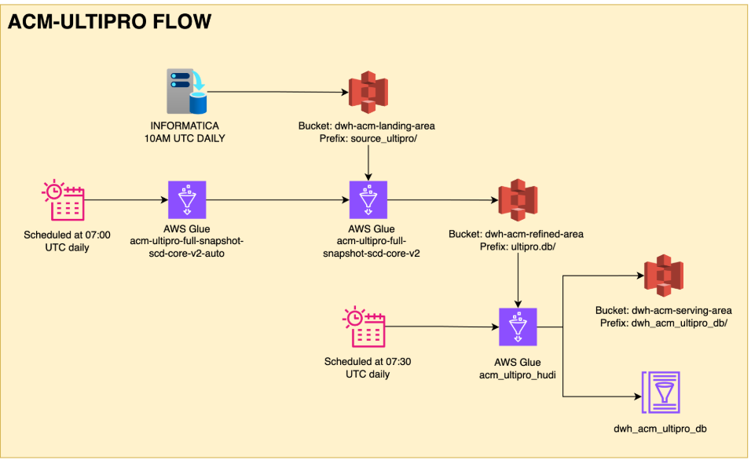
- Job Scheduling: Details on job scheduling, including frequency and dependencies.
(All timings in EST)
- Data for the backup file pulled at 0 hour (3:00 AM and 10 AM)
- 15 In FTP
- 30 Bot
- 31 File Time backup file
- 40 SQL Server loads backup file
- 00 AWS source data extraction and transformation. 55 minutes duration (scheduled at 2:00 AM and 11:00 AM)
- load Qlik (5 minutes) (scheduled at 5:45 and 11:45 AM)
- 12 PM run reports

7 Error Handling and Logging
- Error Handling Procedures: Steps to handle errors during the ETL process.
- Logging Mechanisms: Methods for logging ETL activities and errors.

8 Testing and Validation
- Test Plan: Detailed plan for testing the ETL process.
- Test Cases: Specific test cases and expected outcomes.
- Validation Procedures: Methods for validating data accuracy and completeness.

9 Documentation and Reporting
- Documentation: Comprehensive documentation of the ETL process, including code and configuration files.
- Reporting: Methods for generating and distributing reports on ETL performance and issues.

10 Maintenance and Support
- Maintenance Plan
- To ensure the continued accuracy, reliability, and performance of the Payer Mix Report, the Data Engineering and Analytics teams are responsible for the following ongoing maintenance activities:
- ETL Job Monitoring:
  - Regularly monitor AWS Glue job executions via CloudWatch.
  - Review logs for job failures, delays, or data quality issues.
- Redshift Performance Tuning:
  - Monitor table sizes, query performance, and vacuum operations.
  - Perform regular optimizations, including updating statistics, sort keys, and distribution styles.
- Data Quality Checks:
  - Implement automated validation rules (e.g., row count checks, null checks).
  - Schedule periodic audits to ensure data integrity.
- Security Reviews:
  - Review IAM roles and access permissions quarterly.
  - Monitor and log unauthorized access attempts.
- Data Source Connectivity:
  - Maintain and update ODBC drivers, APIs, and DMS connectors as needed.
  - Test integration endpoints and credentials regularly to avoid failures.
- System Upgrades:
  - Stay current with AWS Glue, Redshift, and Qlik updates and patches.
  - Validate report compatibility after upgrades or new feature releases.
- Backup File Management:
  - Ensure timely ingestion of backup files from FTP locations.
  - Validate backup file structure and content before processing.
Support Procedures
- The support team will follow a structured escalation and resolution procedure to handle production issues efficiently:
- Issue Identification:
  - Detected through automated alerts (AWS CloudWatch), manual user reports, or scheduled audits.
- Logging and Tracking:
  - All issues logged in the internal ticketing system (e.g., Jira, ServiceNow) with timestamps, severity levels, and assigned owners.
- Resolution Timeline:
  - Critical issues (e.g., ETL failure, Redshift down, Qlik not loading): Resolved within 2–4 hours.
  - Medium issues (e.g., delayed reports, data mismatch): Resolved within 1 business day.
  - Low-priority issues (e.g., enhancements, formatting requests): Resolved within 3–5 business days.
- Communication Protocol:
  - Immediate stakeholders (Jon Morrison, Jason Hershey) are notified in case of any production delays or critical issues.
  - Resolution summaries are shared via email or Teams after ticket closure.
- Knowledge Base:
  - Maintain and update SOPs (Standard Operating Procedures) for frequent issues and recurring support tasks.
  - Documentation is stored in a shared Confluence or SharePoint location accessible by the support team.
- Post-Incident Review:
  - A root cause analysis (RCA) is performed for high-severity issues.
  - Lessons learned and preventive measures are documented and shared with the team.

11 Appendices
11.1 Glossary:
Term / Acronym | Definition
NHPPD | Nursing Hours Per Patient Day — total worked hours by nurses divided by resident days.
PCC | Point Click Care — a healthcare platform used for patient records and staff scheduling.
ETL | Extract, Transform, Load — data pipeline process used for integrating data from multiple sources.
AWS Glue | AWS managed ETL service for automating data workflows.
AWS DMS | AWS Database Migration Service — used for replicating data from on-premises/cloud sources to AWS.
Redshift | Amazon Redshift — AWS cloud-based data warehouse used for reporting and analytics.
Qlik Sense | Business Intelligence tool used to visualize NHPPD metrics and reports.
Resident Days | Total number of days residents are present during the reporting period.
Census | The total count of residents per day, including primary and secondary (2nd person) occupancy.
HUDI | Hadoop Upserts Deletes and Incrementals — used for managing slowly changing data.
SCD | Slowly Changing Dimensions — data management technique to track historical changes in data.
FTP | File Transfer Protocol — used for receiving static files like backups and budgets.
IAM | AWS Identity and Access Management — used to control user access and permissions.

11.2 References:
Source | Description
Point Click Care (PCC) | Source for patient census, hours worked, and clinical data.
Ultipro | HR system provides payroll and associate details.
Great Plains (GP) | Financial system for accounting and department-level data.
NetSuite | Source for GL and department budget integration.
AWS Documentation | Technical reference for Glue, DMS, Redshift configuration and troubleshooting.
Qlik Documentation | Guides for dashboard development, publishing, and visualization.
Budget Files (CSV/Excel) | Static data manually uploaded via FTP for budgeting comparisons.
Internal SOPs | Internal Standard Operating Procedures for ETL, QA, and UAT workflows.

12 Technical Details
The technical details include:
Tables, Procedures and Views:
Tables | Procedures | Views
Date table | dim.load_datetable(); | Vwbed
Entity | dim.load_entity(); | Vwcensus
Facility | dim.load_facility(); | Vwbuilding
Campus | dim.load_campus(); | Vwbedoccupancy
Campus active dates | dim.load_campusactivedates(); | Vwbedoccupancy2ndperson
Level-of-care | dim.load_levelofcare(); | Vwdate
Building | dim.load_building(); | Vwdischarges
Unit | dim.load_unit(); | starfactBudgetOccupancyPerDay
Room | dim.load_room(); | vwDepartmentWorkingActualBudget
Bed | dim.load_bed(); | vwdepartment
Resident | dim.load_resident(); | vwdepartmentall
Admission action | dim.load_admissionaction (); | vwfactpayrollbudget
Admission status | dim.load_admissionstatus (); | vwjob
Admission | dim.load_admission(); | vwpayperiodcalendar
Bed occupied | dim.load_bedoccupied(); | vwpayrollsecurityhr
Bedavailable | dim.load_bedavailable(); dim.update_bedavailable();
BedOccupancy | dim.load_bedoccupancy();
Census | dim.load_census();
Department | dim.load_department() ;
Pbj job code | dim.load_pbjjobcode();
HR job code fixed variable | dim.load_hrjobcodefixedvariable() ;
Job | dim.load_job();
Payroll budget | dim.load_payrollbudget();
Pay period | dim.load_payperiod();
Associate | dim.load_associate();
Payroll security | dim.load_payrollsecurity();
Pay type | dim.load_paytype();
Associate pay detail | dim.load_associatepaydetail();
NHPPD budget | dim.load_nhppdbudget();

13 Qlik Reporting Sheets
Please find attached spreadsheets for the Qlik reporting sheets.
Below is the link to the reporting tool
NHPPD_Qlik_Report

14 UAT Cases

Test Case ID | Test Scenario | Test Steps | Expected Result
TC01 | Validate NHPPD formula | 1. Open the report 2. Check the NHPPD column 3. Compare NHPPD = Nursing Hours ÷ Patient Days | NHPPD values match expected formula calculation
TC02 | Validate data for selected date range | 1. Filter report for 01-July-2025 to 07-July-20252. Verify all dates fall within this range | Report shows only data from 01 to 07 July 2025
TC03 | Filter by Facility | 1. Select one Facility from filter2. View report | Only data from selected Facility appears
TC04 | Validate daily totals | 1. Select daily granularity2. Compare Nursing Hours and Patient Days with source data | Daily totals match backend/source data
TC05 | Validate weekly aggregation | 1. Select weekly view2. Compare sum of daily NHPPD vs weekly NHPPD | Weekly NHPPD = (Sum of Nursing Hours for week) ÷ (Sum of Patient Days for week)
TC06 | Validate role-based filtering | 1. Filter by RN role only2. Check Nursing Hours and NHPPD | Only RN hours included in Nursing Hours; NHPPD adjusts accordingly
TC07 | Validate department filtering | 1. Apply filter to a specific department2. Review output | Only records from selected department appear
TC08 | Check NHPPD target flag | 1. Identify rows with NHPPD below threshold2. Verify visual indicator (e.g. red text, flag icon) | Alert appears for rows below target NHPPD
TC09 | Export to Excel/PDF | 1. Export report2. Open downloaded file3. Compare with on-screen report | Exported data matches on-screen report accurately
TC10 | Validate date sorting | 1. Ensure report is sorted by date (ascending/descending) | Date sorting works correctly
TC11 | Performance test | 1. Open report with full year data2. Measure load time | Report loads within acceptable time limit (e.g. <10 sec)
TC12 | Role-based access (RLS) | 1. Login as Nurse Manager for Facility A2. View NHPPD report | User sees only Facility A's data
TC13 | Data refresh validation | 1. Update backend data2. Refresh report3. Check for latest values | Report reflects latest available data
TC14 | Mobile responsiveness (if applicable) | 1. Open report on mobile device/tablet2. Navigate and filter | Report is readable and functional on mobile

15 KPI
NHPPD Budget = Budget Worked Hours - Budget Training Hours / Resident Days Budget
NHPPD = Hours / Resident Days
Occupancy = sum (Resident days)
Budget Occupancy = sum (Resident Days budget)
Census = SUM (Resident Days) + SUM (Second Person)

Version Change Control
Version | Change | Date  (Mo-Day-Year) | Updated  By
Draft V1 | Created draft version of Payer Mix Report | 25-03-2025 | Vaishnavi Lakhera
Draft V1 | Updated community details, Qlik Screenshots, Overview | 27-03-2025 | Vaishnavi Lakhera
Draft V1 | Updated Qlik report snapshots and its link and data sources | 01-04-2025 | Vaishnavi Lakhera
Draft V1 | Updated points highlighted in the mail: 4,5,6,7,10 | 08-04-2025 | Siddharth Mittal
Draft V2 | Updated Jobs and data mapping details | 25-04-2025 | Vaishnavi Lakhera
Draft V2 | Updated data workflow | 30-04-2025 | Vaishnavi Lakhera
Draft V3 | Updated overview | 22-07-2025 | Vaishnavi Lakhera

